

**NÜVE SANAYİ MALZEMELERİ İMALAT VE TİCARET A.Ş.**

**NC 150 / NC 150D**

**HORIZONTAL STEAM STERILIZER**

**SERVICE MANUAL**

**1984**

**Z14.K 25 314 Rev. No: 00 Rev. Date: 09/2021**

**Factory**

Saracalar Mah. Saracalar Kümeevleri No:4/2

Akyurt 06287

**ANKARA**

Phone: +9(0312) 399 28 30

e-mail: nuveservice@nuve.com.tr

CONTENTS

1.INTRODUCTION 6

1.1. Purpose 6

1.2. General Description 6

2. OPERATING FUNCTIONS 8

2.1. Overview 8

2.2. Description of Functions 8

2.2.1. Power supply 8

2.2.2. N-SmArt Programmable Microprocessor Main Structure 8

2.2.3. Display Board 9

2.2.4. Heating Unit 12

2.2.5. Water and Steam Unit 12

2.2.6. Vacuuming unit 13

3. SERVICE 14

3.1. Overview 14

3.2. General Failures 15

3.3. Error Codes and Failures 20

4. SPARE PARTS REPLACEMENT 41

4.2. Main Board Replacement 41

4.3. Display Board Replacement 42

4.4. Air Vent Solenoid Valve Replacement 42

4.5. Chamber Steam Feed Solenoid Valve Replacement 43

4.6. Chamber Safety Valve Replacement 44

4.7. Surface Thermostat Replacement 45

4.8. Temperature Sensor Replacement (PT-CHAMBER (PT-1), PT-CHAMBER AIR DET.) (PT-2) PT-JACKET ( PT-3), PT- GEN(PT- 4)) 45

4.9. Lock Switch Replacement 47

4.10. Lock Coil Replacement 47

4.11. Door Position Switch Replacement 48

4.12. AC/DC Converter Card Replacement 48

4.13. SSR Replacement 49

4.14. Thermal Relay Replacement 49

4.15. Automatic Fuse Replacement 50

4.16. Steam Generator Electronic Water Level Board Replacement 50

4.17. Digital Safety Thermostat Replacement 51

4.18. Steam Discharge Solenoid Valve Replacement 52

4.19. Steam Discharge / Vacuum Bridge Solenoid Valve Replacement 53

4.20. Vacuum Pump Solenoid Valve Replacement 54

4.21. Gasket Steam Filling Solenoid Valve Replacement 55

4.22. Steam Generator Water Filling Solenoid Valve Replacement 56

4.23. Water Pump Replacement 57

4.24. Water Level Sensors Replacement 58

4.25. Steam Generator Heater Replacement 59

4.26. Steam Generator Pressure Manometer Replacement 60

4.27. Steam Generator Safety Valve Replacement 61

4.28. Check Valve Replacement 62

4.29. Pressure Sensor Replacement 63

4.30. Vacuum Pump Replacement 64

4.31. Cooling Fan Replacement 65

4.32. Condenser Replacement 65

4.33. Steam Trap Replacement 66

4.34. Compressor (Ecovat) Replacement 67

4.35. Water Level Float Replacement 67

4.36. Gasket Replacement 68

4.37. Jacket Heater Replacement 68

5. ELECTRICAL CIRCUIT DIAGRAM 69

5.1.NC 150 / NC 150D Electrical Circuit Diagram 69

1.INTRODUCTION

## Purpose

This manual contains maintenance and service information for the NC 150 / NC 150D steam sterilizers. It should only be used by service staff trained by Nüve. This manual provides the service staff with information regarding operating principles of the NC 150 / NC 150D autoclave devices and the methods for fixing failures. This manual also covers spare part replacement.

Please contact Nüve Technical Services for problems not identified in the manual.

## General Description

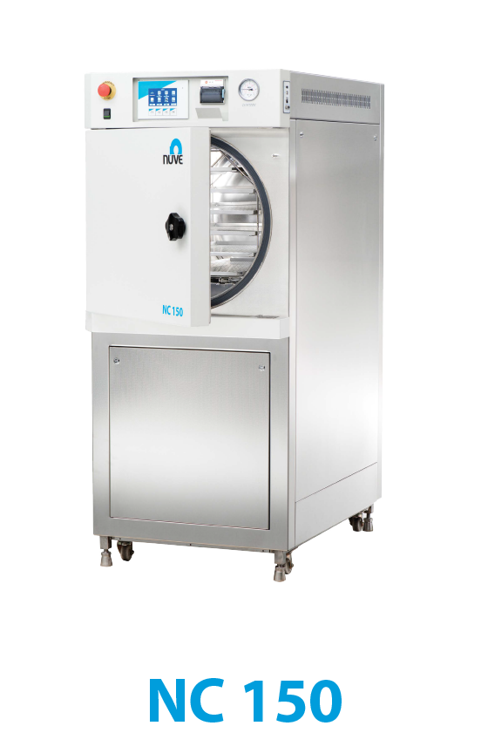

**Figure 1**

Heating function in NC 150 / NC 150D steam sterilizers is provided by steam generator and heater located around the sterilization chamber. Sterilization cycle in NC 150 / NC 150D steam sterilizers consists of vacuuming, heating, sterilization, steam discharge and drying stages.

**Gasket steam feed:** The gasket is pumped up to a certain pressure level by means of a compressor upon starting the program.

**Vacuuming:** Once the program is started vacuuming starts and chamber pressure is reduced below ambient pressure and the air in the chamber is discharged.

**Heating:** Heating of the chamber with steam to reach sufficient steam temperature before sterilization.

**Sterilization:** Sterilization starts when the steam temperature reaches the set temperature. The sterilization chamber remains at this temperature and pressure during the set duration.

**Steam discharge:** Steam discharge is the stage at which the current pressure after sterilization is reduced to the ambient pressure by discharging the steam in the chamber.

**Drying:** Drying is the stage at which the moisture is removed from the chamber by reducing the chamber pressure below the ambient pressure after steam discharge.

2. OPERATING FUNCTIONS



## 2.1. Overview

NC 150 / NC 150D steam sterilizers can be analyzed in 6 main groups by structure.

* Power supply
* N-SmArt Programmable Microprocessor Main Structure
* Display board
* Heating unit
* Water and steam unit
* Vacuuming unit.

## 2.2. Description of Functions

### 2.2.1. Power supply

Power supply for NC 150 / NC 150D devices are given in Table 1.

|  |  |  |  |  |  |
| --- | --- | --- | --- | --- | --- |
| **MODEL** | **Thermic**  **Power Switch** | **Installed Power** | **Power Input** | **Chamber Heater** | **Steam Generator Heater** |
| NC 150 / NC 150D | 3 x 25A | 11500 W | 400 V~ 50 Hz. | Laminar Heater  4* 500 W | 9000 W |

**Table 1**

### 2.2.2. N-SmArt Programmable Microprocessor Main Structure

NC 150 / NC 150D horizontal steam sterilizers operate with N-SmArt Programmable Microprocessor. N-SmArt Programmable Microprocessor main structure comprises the following parts:

* N-SmArt Programmable Microprocessor Main Board
* Steam generator water level board
* Display board

**2.2.2.1. N-SmArt Programmable Microprocessor Main Board**

N-SmArt Programmable Microprocessor main board in NC 150 / NC 150D works with the “proportional” control system. The main board sets the steam generator according to the initially selected program (set +4°C). Then, vacuuming is initiated upon start of the program by the user. The air in the chamber is discharged by reducing the chamber pressure below the ambient pressure. Following vacuuming; heating, sterilization, steam discharge and drying stages are performed by the main board as described in Section 1.2.

N-SmArt programmable microprocessor main board controls sterilization based on the measurement values from temperature and pressure sensors placed in the sterilization chamber of the device. It sets the steam generator according to the selections made by the user on the display board.

**2.2.2.2. Steam Generator Water Level Board**

Steam generator water level board operates in connection with water level sensors in the steam generator. When the water level in the steam generator is at minimum, it provides the steam generator with water feed. When the water level in the steam generator reaches maximum level, water feeding is cut off.

### 2.2.3. Display Board

Display board allows us to display the follow-up of values measured by temperature and pressure sensors placed in various points of NC 150 / NC 150D horizontal steam sterilizers, to read the water level information of the steam generator; to select and follow-up a program. In addition, WIFI module is included in this board as standard.

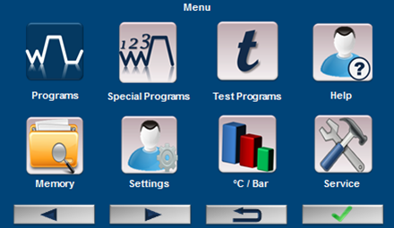

Figure 2

Since the functions of F1, F2, F3, F4 buttons vary in connection with the commands written on the board, they are denoted by "F", the first letter of the word function.

After the on-off switch of the device is powered-up a white screen appears where NUVE emblem shows up first and the device is turned on.

**2.2.3.1. Service Menu**

|  |  |
| --- | --- |
| C:\Users\Mehmet.Guzel\Desktop\Resim1.png | On menu screen, proceeding to "**Service** using left (F1) and right (F2) buttons" and pressing confirm button (F4) takes to service password query screen page. |

**Figure 3**

Upon entering service password (2111), service page opens. Service page includes submenus for Calibration, PID Parameters, Updating, Input-Output Status, Ethernet and Factory Settings.

**2.2.3.2. Calibration**

|  |  |
| --- | --- |
| warning | Before application of calibration procedure, actual temperature and pressure should be measured inside the chamber. |

|  |  |
| --- | --- |
| warning | The point described and applied in the following procedure covers the sterilization chamber. |

Actual temperature and pressure measurement procedure:

* Place calibrated external sensor in the midpoint of sterilization chamber.
* Power up the device.
* Select suitable sterilization program for the temperature value at which you wish to calibrate.
* START the program once you see the message "SYSTEM READY" for the selected program in the stage section on the screen.
* Note the temperature and pressure values on the screen when the device switches to "**sterilization** stage.
* After the sterilization program is completed, compare the values recorded through the external sensor placed inside the sterilization chamber at the sterilization stage with the values you read on the screen and apply the following calibration procedure:

|  |  |  |
| --- | --- | --- |
| 1. | On the service page go to "Calibration" with up (F1) and down (F2) buttons and press confirm button (F4), then you will go to "Calibration" screen on the right which includes temperature and pressure selection. | **Figure 4** |
| 2. | On the calibration page, go to submenu using up (F1) and down (F2) buttons which you want to calibrate and make a selection with the confirm button (F4). |
| 3. | When Temperature Calibration page is selected, "Temperature Calibration" screen appears as shown on the right. | metin, ekran görüntüsü, işaret, kapat içeren bir resim  Açıklama otomatik olarak oluşturuldu  **Figure 5** |
| 4. | Go to Chamber Temperature line using Switch (F3) button. Enter the intended calibration value in the "calibration value" line with up (F1) and down (F2) buttons. Calibration value is the temperature difference between the temperature value measured by the external sensor and that on the device screen. For example, if the device screen shows 135.5°C and the external sensor reads 134.5°C, |
|  | -1.0°C should be entered for calibration value. If the device screen shows 134.5°C and the external sensor reads 135.5°C, +1.0°C should be entered for calibration value. | |
| 5. | Once you enter the values exit page using Confirm button (F4). | |

**2.2.3.3.** **Ethernet**

|  |  |
| --- | --- |
| metin, işaret, ekran görüntüsü içeren bir resim  Açıklama otomatik olarak oluşturuldu  **Figure 6** | On the Service page, go to "Ethernet" section using up (F1) and down (F2) buttons and press confirm button (F4), "Ethernet" screen will appear. If NüveCloserTM software and/or e-mail feature will be used, Ethernet parameters should be set on the display on the left. |

|  |  |
| --- | --- |
| warning | After completing ethernet settings turn off and on your device. |

### 2.2.4. Heating Unit

Heating in sterilization chamber of NC 150 / NC 150D steam sterilizers is provided by foil heaters located in the outer jacket of the chamber and surrounded by glass wool, and the steam generator. A safe operation is ensured thanks to surface thermostats located on the jacket heaters and a safety valve located on the steam generator. Heating unit is controlled by microprocessor controlled main board and mechanical and electrical protection as well as software protection is also available.

### 2.2.5. Water and Steam Unit

In NC 150 / NC 150D steam sterilizers which make sterilization with pressurized steam, the steam is generated by heating and boiling softened/distilled water taken into steam generator from the reserve tank.

Steam filling, steam discharge, air vent and vacuum line solenoid valves on the unit are controlled by microprocessor main board.

Sterilization chamber safety valve is activated when the pressure inside the sterilization chamber exceeds 3 Bars due to any malfunction and automatically discharges the steam inside the chamber that causes excessive pressure.

Level of softened/distilled water taken into the steam generator is controlled by two water level electrodes (minimum/maximum). Heating in a steam generator with sufficient level of water is provided by a set of heaters. The steam trap on the steam generator ensures discharge of condense formed due to condensation in the generator and the safety valve, in cases where pressure cannot be controlled, automatically discharges the steam that causes excessive pressure.

Steam generator heating thermal switches off and protects the user and device in case of any failure in any of mains phases or in heaters.

Minimum water level is controlled by water-gauge in the reserve tank in which the water required for steam generator filled.

Water unit elements are listed below:

* Reserve tank
* Water pump
* Water filling solenoid valve
* Check valve

Steam unit elements are listed below:

* Steam generator
* Manometer
* Pressure transmitter
* Water level sensors
* Steam trap
* Safety Valve (3 Bars)
* Steam generator water level board

### 2.2.6. Vacuuming unit

In NC 150 / NC 150D steam sterilizers, the air in the sterilization chamber is discharged from the chamber by means of a vacuum pump. Vacuum line consists of diaphragm vacuum pump, condenser and solenoid valves.

Vacuuming unit elements are listed below:

* Vacuum line solenoid valve
* Vacuum / steam discharge bridge solenoid valve
* Vacuum Pump
* Condenser / condenser fan

3. SERVICE

|  |  |
| --- | --- |
| warning | Please take the necessary safety precautions for environmental health and your own safety before starting the service operations. Please comply with the warnings on the device. |

## 3.1. Overview

Various failures which may be encountered when using NC 150 / NC 150D steam sterilizers can be eliminated by the help of the table below.

Most potential failures can be detected with a multimeter.

In case of an error, the screen turns red and the type of error is written on the screen. Device errors are recorded in device memory. The date and time of these errors can be viewed along with the respective error codes. Error history page can be reached from the main menu using the memory option.

Elements cannot be changed in failures arising from main board and display board.

Before replacing the board or other command and control elements, please make sure that the failures are not caused by cables or loose contacts in the terminal connections.



## 3.2. General Failures

**On-off switch is on, there is no image on the display board.**

**On-off switch is on, some pixels do not light.**

**The device consistently causes fuse blows.**

3)

**The sterilization chamber pressure is not rising.**

**Steam leaks from the lid.**

**The device does not discharge steam.**

**Samples come out wet at the end of sterilization cycle.**

**NOTE:** If sterilization is performed in a way so that the materials are bagged; plastic parts should touch plastic parts and paper parts should touch paper parts.

If sterilization bags are big, paper parts should be loaded so as to face the ground.

## 3.3. Error Codes and Failures

**Error 01- Vacuum Time Exceeded**

**Error 02-Chamber Air Detector**

**Error 03- Steam Discharge Time Exceeded**

**Error 04- Air vent time exceeded.**

**Error 05- Discharge door is open**

**Error 06- Door Open**

**Error 07- Overheat in the Steam Generator**

**Error 09- Insufficient water in the generator**

**Error 10- Sensor Failure PT1, PT2, PT3, PT4, BT1, BT2, BT3**

**Error** **11-Pre-heating failure**

**Error 12- High Pre-heating Temperature**

**Error 14- Door Locking**

**Error 16- Power Failure**

**Error 17- Heater malfunction**

**Error 18- High steam generator pressure**

**Error 19- Low Temperature**

**Error 20- High Temperature**

**Error 21- Low Pressure**

**Error 22- High Pressure**

**Error 23- Door lock could not be unlocked**

**Error 24- Low gasket pressure**

**Error 25- High gasket pressure**

**Error 26- Generator water level**

**Error 27- Insufficient water in the tank**

**Error 29- Gasket air filling**

**Error 30- Steam feed**

**Error 31- Gasket air intake**

**Error 32- Vacuum test high temperature**

**Error 33- Power cut sterilization cancelled**

**Error 34- Power cut sterilization continued**

**Error 44- Incompatible main board version**

**Error 46- Gasket**

**Error 47- Hepa filter**

**Error 48- Communication error**

**Error 49- SMS**

**Error 50- Modem**

**4. SPARE PARTS REPLACEMENT**

|  |  |
| --- | --- |
| warning | Disconnect the device from the power supply before replacing any part. |

|  |  |
| --- | --- |
| warning | For the next steps from here on, remove the closing sheet by pulling clamping locks on both sides of the closing sheet at the top of the device towards inside. |

|  |  |
| --- | --- |
| warning | Use a liquid gasket (Loxeal 55-37 should be used) or a teflon tape to ensure tightness. |



## Main Board Replacement

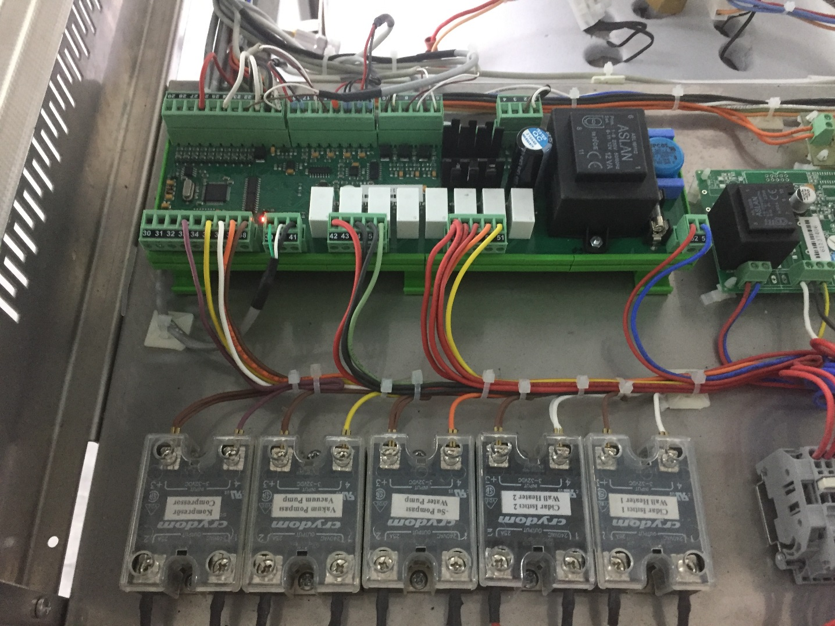

**Figure 7**

* Remove all the cable terminals connected to the main board connectors.
* Remove the tabs that keep the main board on the rails.
* Mount the new board and carefully make the terminal connections in accordance with the electrical circuit diagram.
* Do not forget to select the device from Menu > service (password: 2111) > factory settings (password: 1968).

## Display Board Replacement

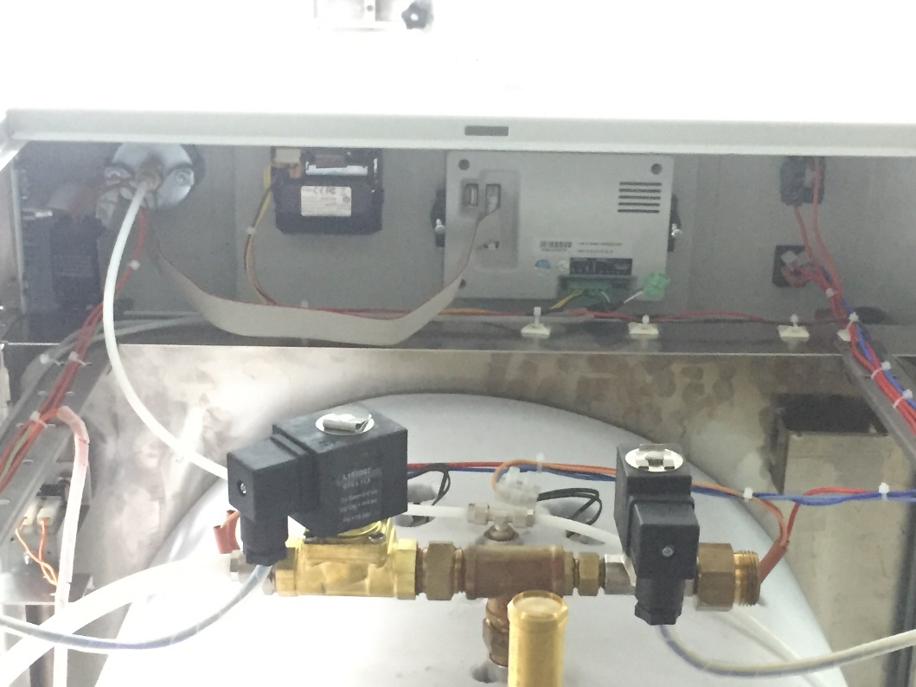

**Figure 8**

* Separate the display board connection cables from the display board.
* Unscrew 2 connecting screws on two sides of the display board and remove the display board.
* Locate the display board onto the panel sheet and mount it using the 2 screws.
* Affix connection cables.
* Do not forget to select the device from Menu > service (password: 2111) > factory settings (password: 1968).

## Air Vent Solenoid Valve Replacement

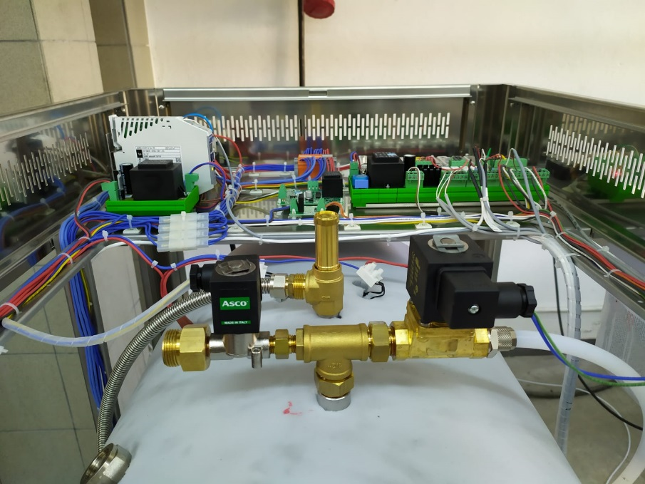

**Figure 9**

* Disassemble the microbiological filter connected to the air vent solenoid valve.
* Remove the air vent solenoid valve coil socket by unscrewing.
* Separate the valve from the line by disassembling solenoid valve connection adapters.
* Disassemble connection adapters in the inlet and outlet of the solenoid valve and assemble them on the new solenoid valve.
* Assemble new solenoid valve in the arrow direction as shown in the figure.
* Assemble solenoid valve coil socket.

## Chamber Steam Feed Solenoid Valve Replacement

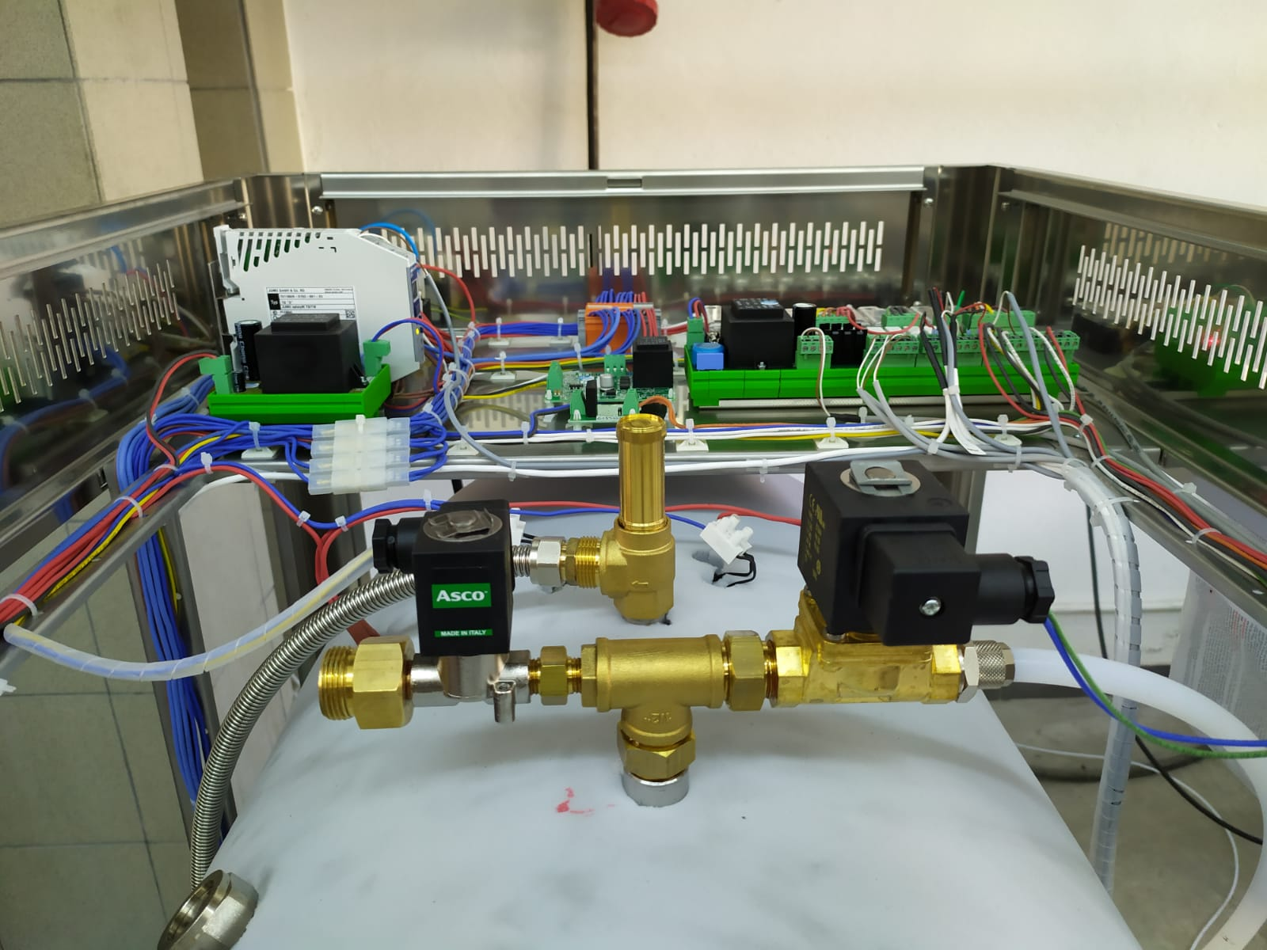

**Figure 10**

* Make sure that steam generator pressure is zero before replacing chamber steam feed solenoid valve.
* Separate chamber steam feed solenoid valve coil socket by unscrewing.
* Separate solenoid valve inlet and outlet hoses by loosening connecting nuts.
* Disassemble connection adapters in the inlet and outlet of the solenoid valve and assemble them on the new solenoid valve.
* Assemble new solenoid valve in the arrow direction and as shown in the water and steam unit flowchart.
* Assemble solenoid valve coil socket.

## Chamber Safety Valve Replacement

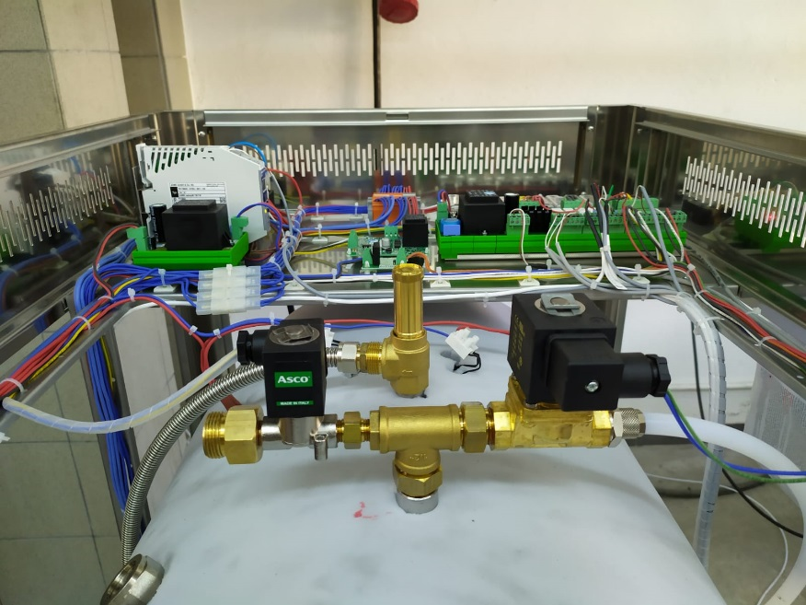

**Figure 11**

* Make sure that there is no pressure in the chamber before disassembling safety valve.
* Disassemble the connection nut on the safety valve by fixing safety valve outlet hose adapter.
* Disassemble safety valve by rotating towards the left by the help of a wrench.
* Ensure tightness.
* Carefully mount the new safety valve.

## Surface Thermostat Replacement

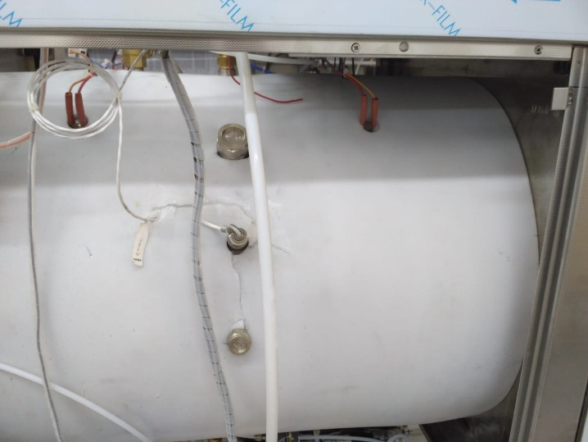

**Figure 12**

* Carefully disconnect the surface thermostat terminal connections.
* Disassemble the thermostat.
* Assemble new surface thermostat and carefully make terminal connections.

## Temperature Sensor Replacement (PT-CHAMBER (PT-1), PT-CHAMBER AIR DET.) (PT-2) PT-JACKET ( PT-3), PT- GEN(PT- 4))

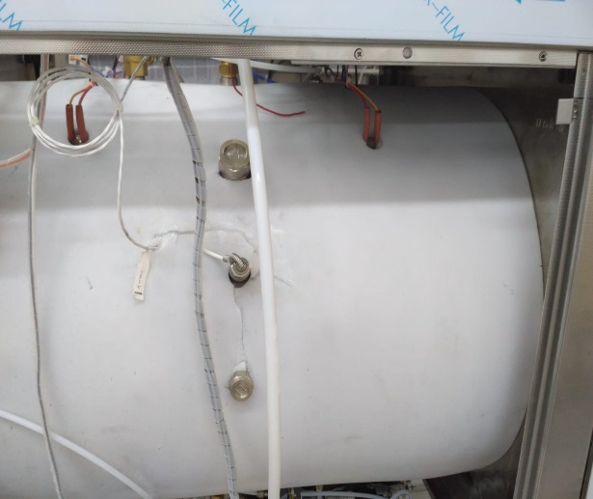

**Figure 13: PT-CHAMBER (PT-1)**

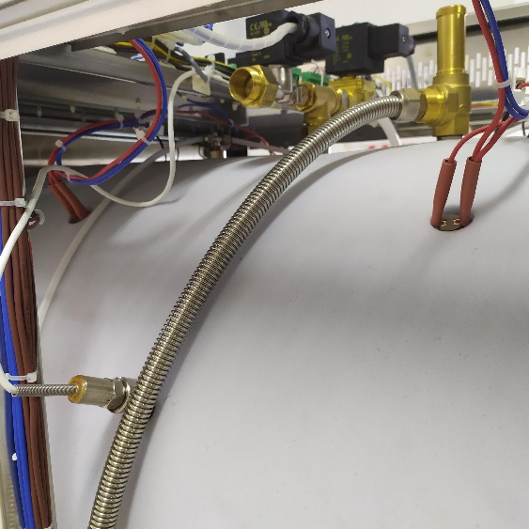

**Figure 14: PT-CHAMBER AIR DET. (PT-2)**

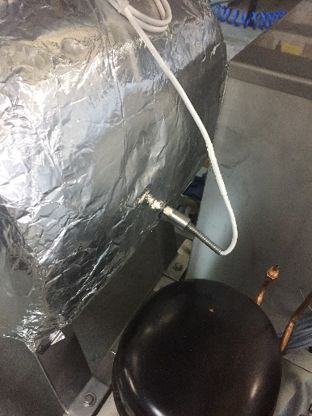

**Figure 15: PT-GEN (PT-4)**

* Disconnect electrical connection cables of malfunctioned temperature sensor from the main board. (Do not forget to disconnect safety thermostat connection when disconnecting generator temperature sensor.)
* Remove temperature sensor and assemble a new one.
* Ensure tightness of new temperature sensor. (Make sure to not twist the connection cable.)
* Carefully make the temperature sensor terminal connections in accordance with the electrical circuit diagram.

## Lock Switch Replacement

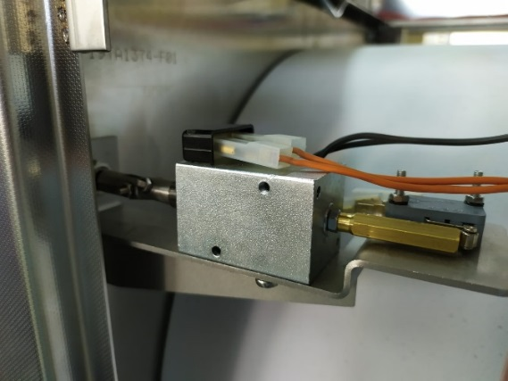

**Figure 16**

* Disconnect the lock switch terminal connections.
* Separate the lock switch from the sheet by unscrewing the connection screws.
* Mount the new door switch.
* Carefully make the door switch terminal connections in accordance with the electrical circuit diagram.

## Lock Coil Replacement

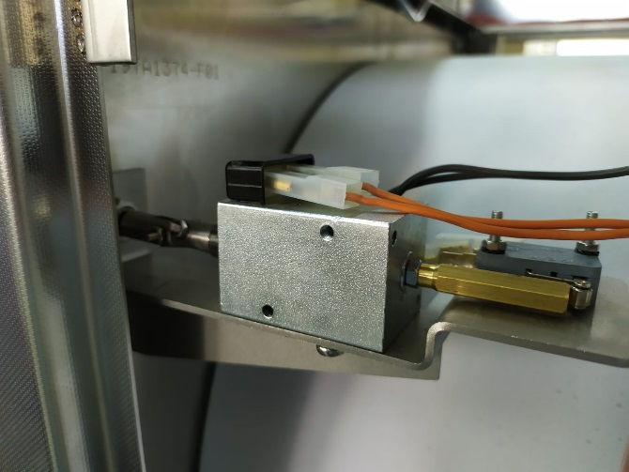

**Figure 17**

* Disconnect the lock coil terminal connections.
* Separate the lock coil from the mounting sheet by unscrewing the connection screws.
* Disassemble mechanisms on the locking coil pin and assemble them on the new locking coil pin.
* Mount the new locking coil.
* Carefully make the locking coil terminal connections in accordance with the electrical circuit diagram.

## Door Position Switch Replacement

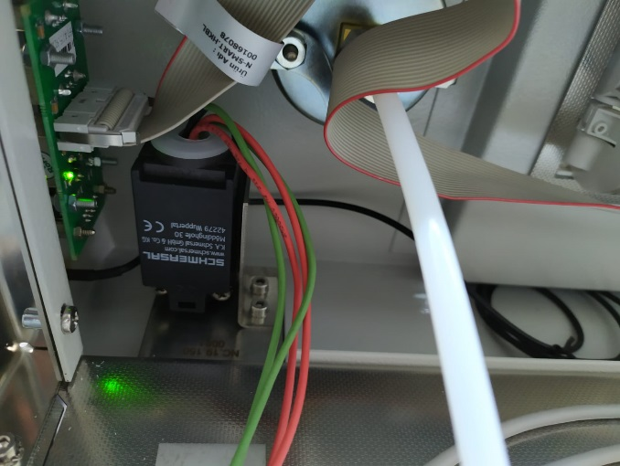

**Figure 18**

* Disconnect position switch cables.
* Remove the nuts providing connection to the sheet from the screws.
* Make the screw connections of the new switch.
* Make the cable connections of the new switch.

## AC/DC Converter Card Replacement

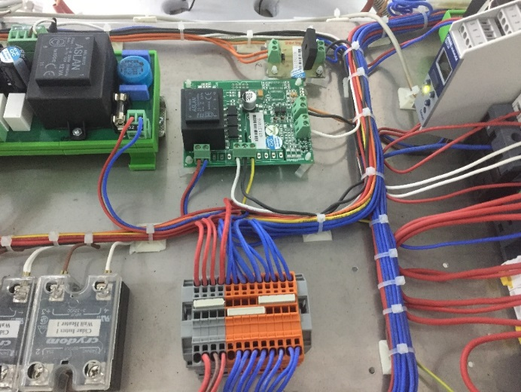

**Figure 19**

* Disconnect the cables from the connectors of the AC/DC converter card.
* Remove the card from the clips on which the card was mounted.
* Mount the new card on the clips.
* Make the cable connections in accordance with the electrical circuit diagram.

## SSR Replacement

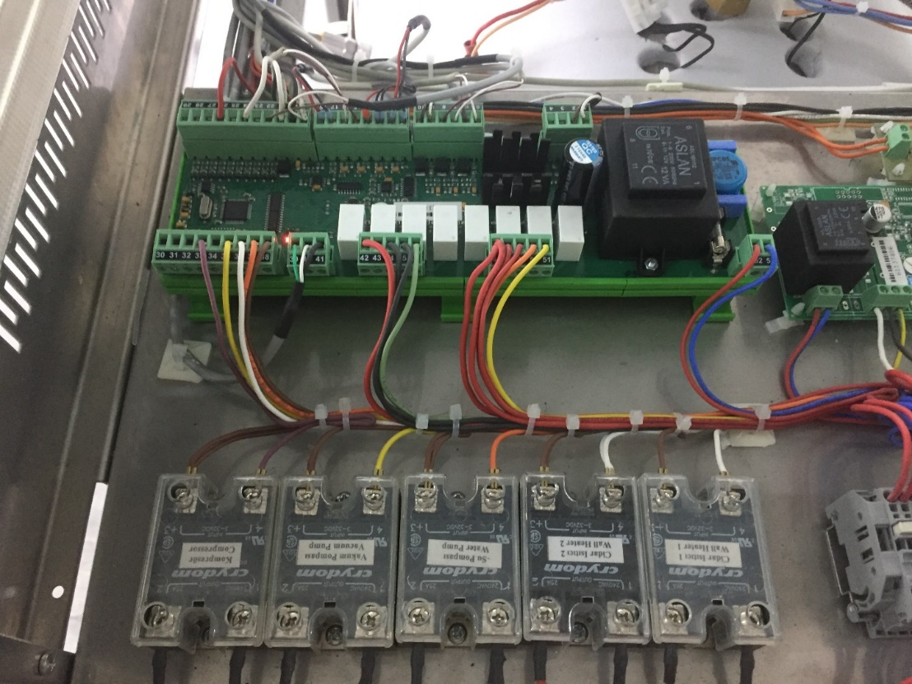

**Figure 20**

* Remove SSR terminal connections.
* Unscrew SSR connection screws and remove the SSR.
* Mount the new SSR and make the terminal connections in accordance with the electrical circuit diagram.

## Thermal Relay Replacement

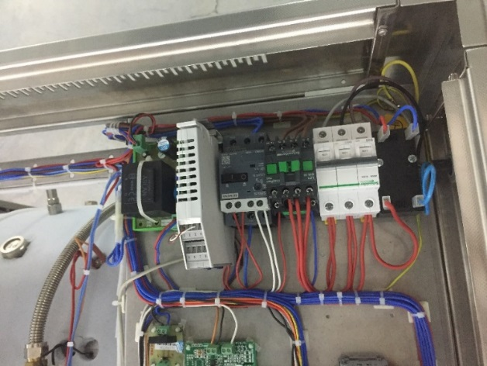

**Figure 21**

* Remove thermal relay electrical connection terminals.
* Hold the thermal relay at its body and move upwards and remove from the steel rail.
* Carefully make and place thermal relay terminal connections in accordance with the electrical circuit diagram.

## Automatic Fuse Replacement

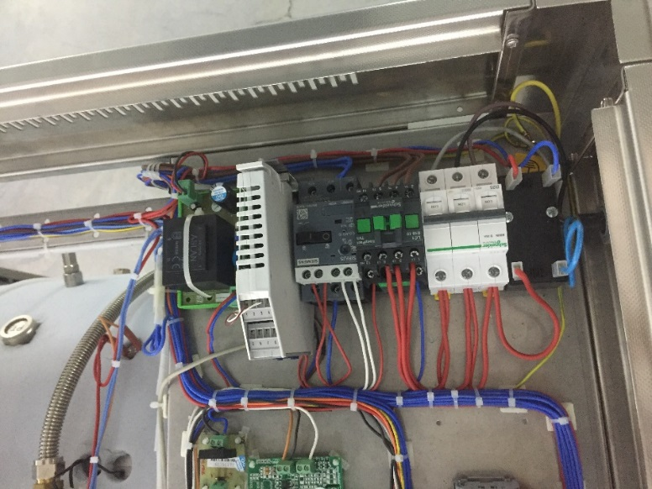

**Figure 22**

* Disassemble automatic fuse electrical terminal connections.
* Pull the fixing clips on the automatic fuse by means of a screwdriver and remove the automatic fuse over the steel rail.
* Carefully make and place the new automatic fuse terminal connections in accordance with the electrical circuit diagram.

## Steam Generator Electronic Water Level Board Replacement

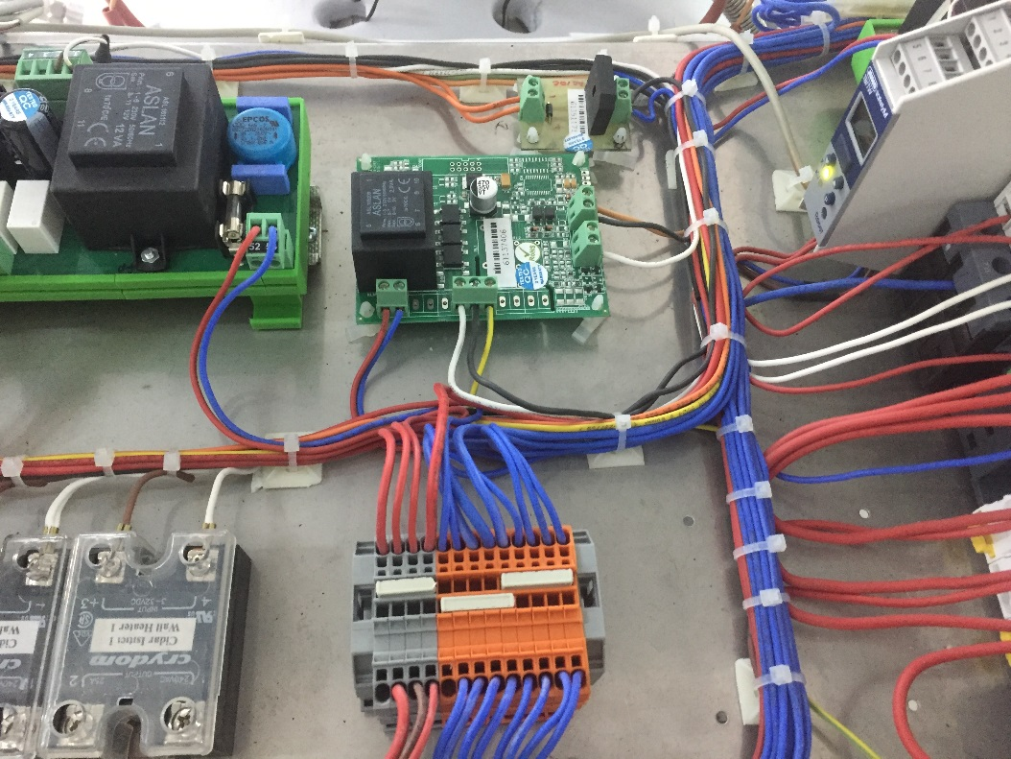

**Figure 23**

* Remove all the cable terminals connected to the water level board connectors.
* Remove the board by disassembling it from the connecting clips on its corners.
* Mount the new board and carefully make the terminal connections in accordance with the electrical circuit diagram.

## Digital Safety Thermostat Replacement

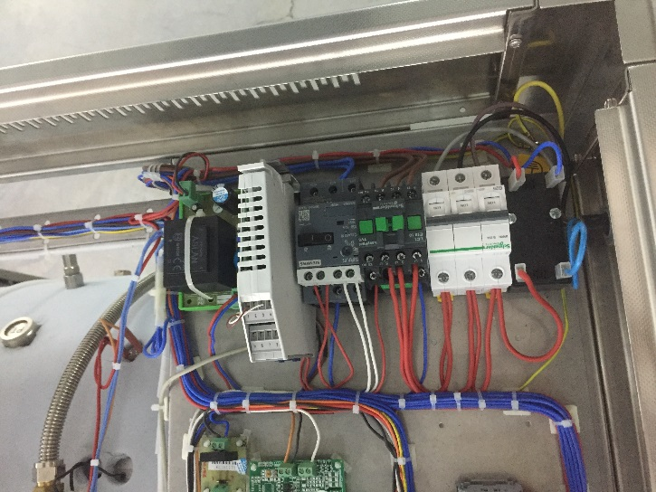

**Figure 24**

* Disconnect all cable terminals connected to digital safety thermostat.
* Remove digital safety thermostat by disassembling mounting sheet.
* Mount the new thermostat and carefully make the terminal connections in accordance with the electrical circuit diagram.

|  |  |
| --- | --- |
| warning | For the next steps from here on, remove the sheets on the left, right and in the front. |

## Steam Discharge Solenoid Valve Replacement

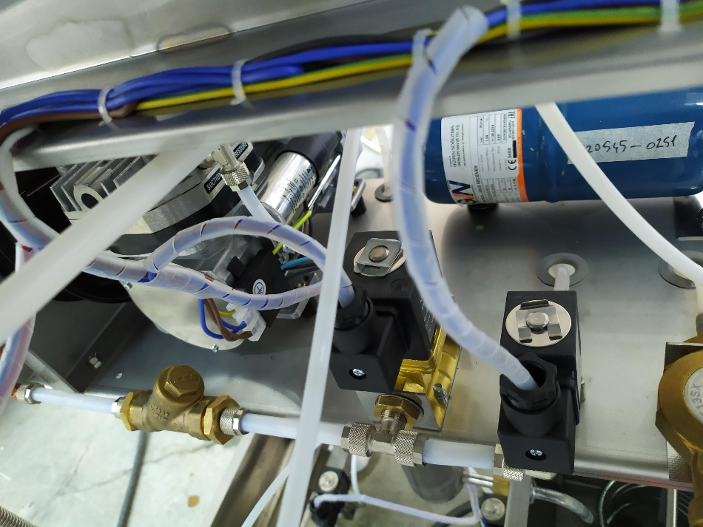

**Figure 25**

* Remove the steam discharge solenoid valve coil socket by unscrewing.
* Unscrew solenoid valve assembly screw at the bottom of the device.
* Separate solenoid valve inlet and outlet hoses by loosening connecting nuts.
* Disassemble connection adapters in the inlet and outlet of the solenoid valve and assemble them on the new solenoid valve.
* Assemble new solenoid valve in the arrow direction and as shown in the water and steam unit flowchart.
* Assemble solenoid valve coil socket.

## Steam Discharge / Vacuum Bridge Solenoid Valve Replacement

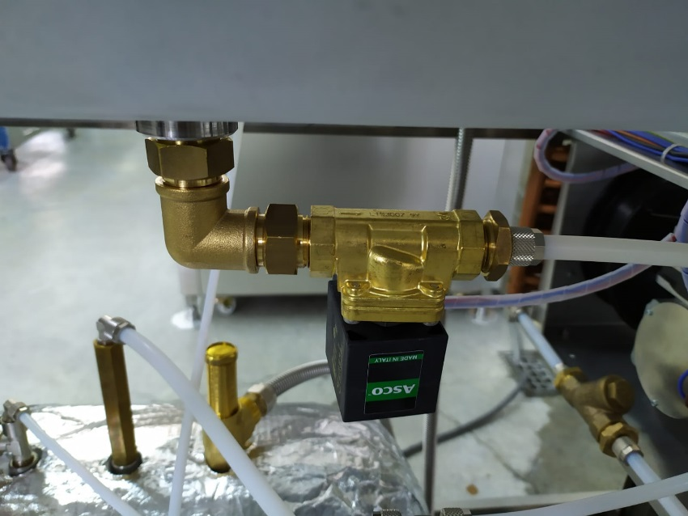

**Figure 26**

* Remove the steam discharge / vacuum bridge solenoid valve coil socket by unscrewing.
* Separate solenoid valve inlet fitting and outlet hose by loosening connecting nuts.
* Disassemble connection adapters in the inlet and outlet of the solenoid valve and assemble them on the new solenoid valve.
* Assemble new solenoid valve in the arrow direction and as shown in the water and steam unit flowchart.
* Assemble solenoid valve coil socket.

## Vacuum Pump Solenoid Valve Replacement



**Figure 27**

* Remove the vacuum pump solenoid valve coil socket by unscrewing.
* Separate solenoid valve inlet and outlet hoses by loosening connecting nuts.
* Disassemble connection adapters in the inlet and outlet of the solenoid valve and assemble them on the new solenoid valve.
* Assemble new solenoid valve in the arrow direction and as shown in the water and steam unit flowchart.
* Assemble solenoid valve coil socket.

## Gasket Steam Filling Solenoid Valve Replacement

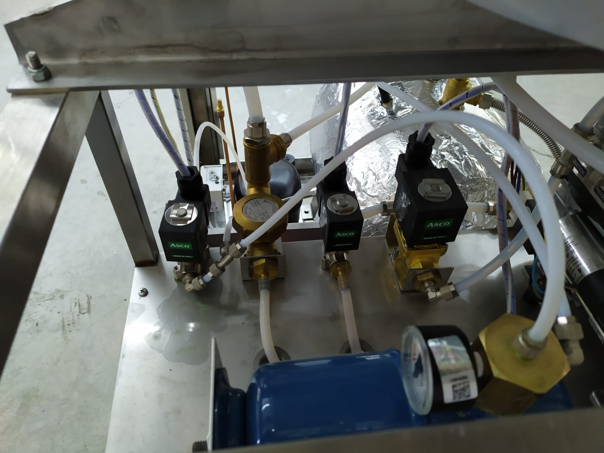

**Figure 28**

* Separate the gasket steam filling valve from the mounting sheet.
* Separate solenoid valve inlet and outlet hoses by loosening connecting nuts.
* Disassemble connection adapters in the inlet and outlet of the solenoid valve and assemble them on the new solenoid valve.
* Assemble new solenoid valve in the arrow direction and as shown in the water and steam unit flowchart.
* Assemble solenoid valve coil socket.

## Steam Generator Water Filling Solenoid Valve Replacement

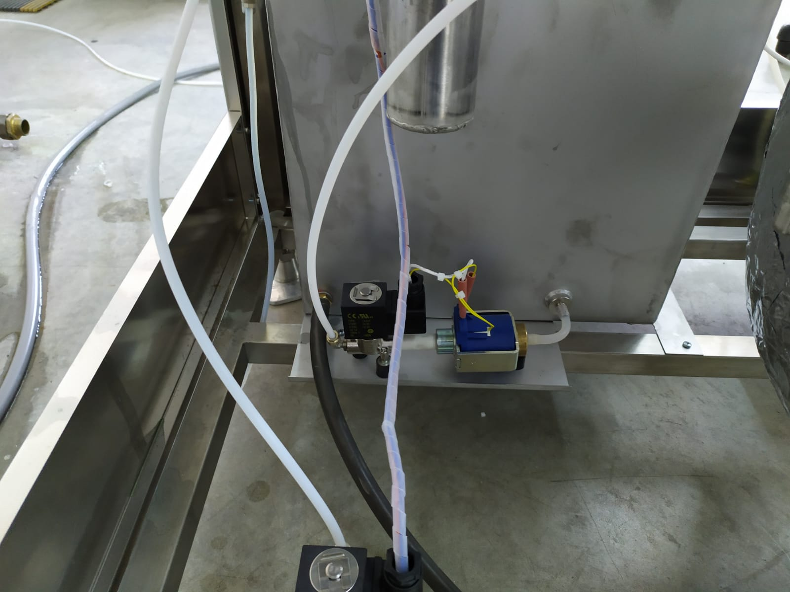

**Figure 29**

* Make sure that steam generator pressure is zero before replacing steam generator water filling solenoid valve.
* Remove the solenoid valve coil socket by unscrewing.
* Unscrew solenoid valve and water pump assembly screw at the bottom of the device.
* Disassemble solenoid valve water pump by keeping it firm and separate connection adapters on it.
* Assemble connection adapters to new solenoid valve input and output using teflon gasket or spreading Loxeal 55/37.
* Assemble new solenoid valve in the arrow direction and as shown in the water and steam unit flowchart.
* Assemble solenoid valve inlet hose and water pump connection so as to ensure tightness.
* Carefully mount the solenoid valve coil socket.

## Water Pump Replacement



**Figure 30**

* Separate water pump electrical connection and water filling solenoid valve coil socket.
* Disconnect water pump inlet hose and disconnect solenoid outlet hose.
* Unscrew water pump and water pump solenoid valve assembly screw at the bottom of the device.
* Disassemble water pump solenoid valve by keeping it fixed. Remove the fitting on it and assemble the valve by affixing the fitting to the new valve.
* Connect the new water pump to the solenoid valve and locate it, carefully make hose and electrical connections.

## Water Level Sensors Replacement

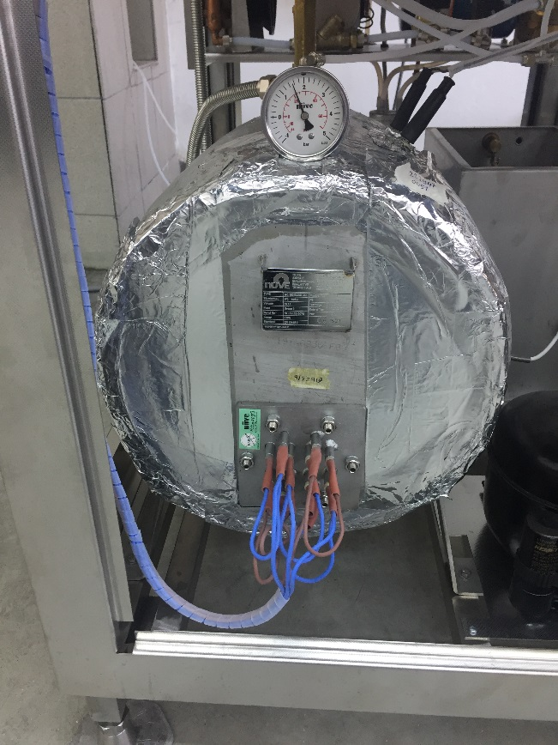

**Figure 31**

* Disconnect generator water level sensors electrical connection terminals.
* Disassemble and remove water level sensor.
* Disassemble water level sensor rod and mount new water level sensor.
* Assemble new water level sensor.
* Carefully make the electrical terminal connections in accordance with the electrical circuit diagram.

## Steam Generator Heater Replacement

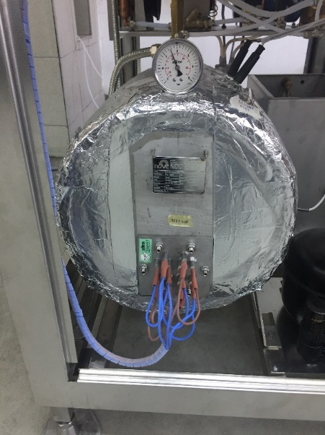

**Figure 32**

* Make sure that steam generator pressure is zero before replacing heater. After checking that steam generator pressure is zero, discharge steam generator by tapping the service valve. (Remove generator pressure hose for discharging water easily.)
* Disconnect heater terminal cables.
* Disconnect 6 screws that fix the heater using a box wrench no. 13 and remove the heater from the generator.
* Mount new heater gaskets to the new heater.
* Mount the new heater to the generator.
* Make the terminal connections of steam generator heater in accordance with the electrical circuit diagram.

## Steam Generator Pressure Manometer Replacement

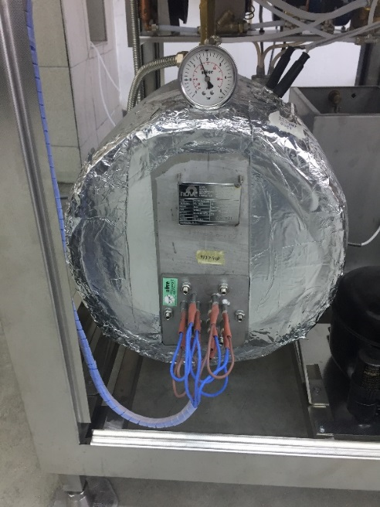

**Figure 33**

* Make sure that steam generator pressure is zero before replacing manometer.
* Remove the manometer by rotating with a wrench.
* Ensure tightness of the new manometer.
* Mount the new manometer.

## Steam Generator Safety Valve Replacement

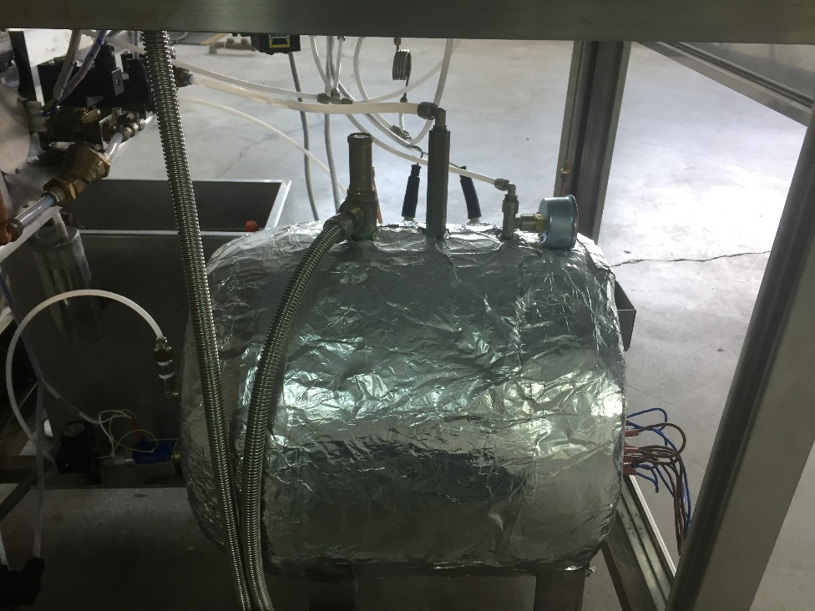

**Figure 34**

* Make sure that there is no pressure in the steam generator before disassembling safety valve.
* Disassemble the connection nut on the safety valve by fixing safety valve outlet hose adapter.
* Disassemble safety valve by rotating towards the left by the help of a wrench.
* Ensure tightness of safety valve.
* Carefully mount the new safety valve.

## Check Valve Replacement

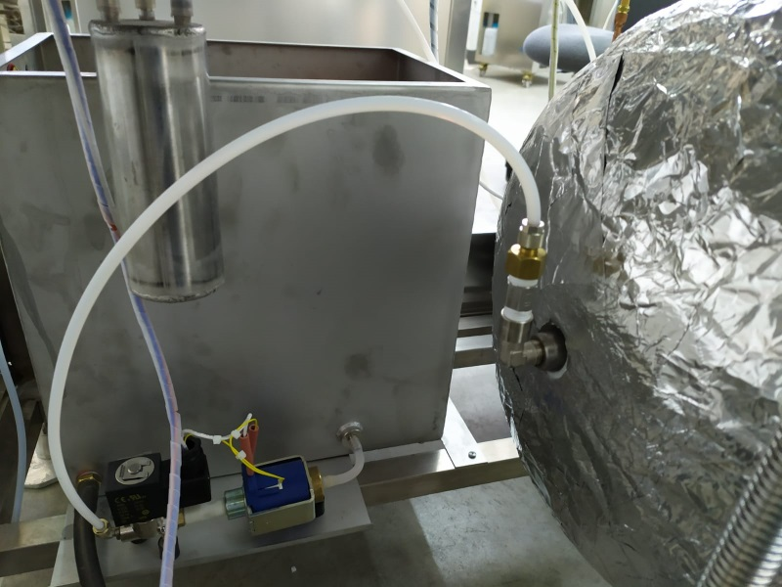

**Figure 35**

* Make sure that steam generator pressure is zero before replacing check valve.
* Disconnect check valve inlet hose.
* Disconnect the hose fitting from the check valve.
* Remove the check valve.
* Ensure tightness of the check valve.
* Assemble the check valve considering the arrow direction.
* Mount the hose fitting and hose.

## Pressure Sensor Replacement

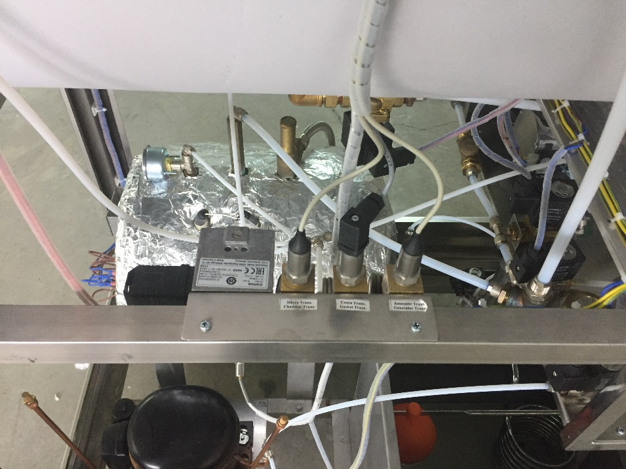

**Figure 36**

* Make sure that steam generator pressure is zero before replacing steam generator pressure sensor.
* Separate the gasket pressure sensor from the socket input.
* Carefully disconnect the terminal connections of the pressure sensor from the board in accordance with the electrical circuit diagram.
* Disassemble pressure sensor by removing connecting nut.
* Carefully mount the new pressure sensor.
* Carefully make the new pressure sensor connection in accordance with the electrical circuit diagram.

## Vacuum Pump Replacement

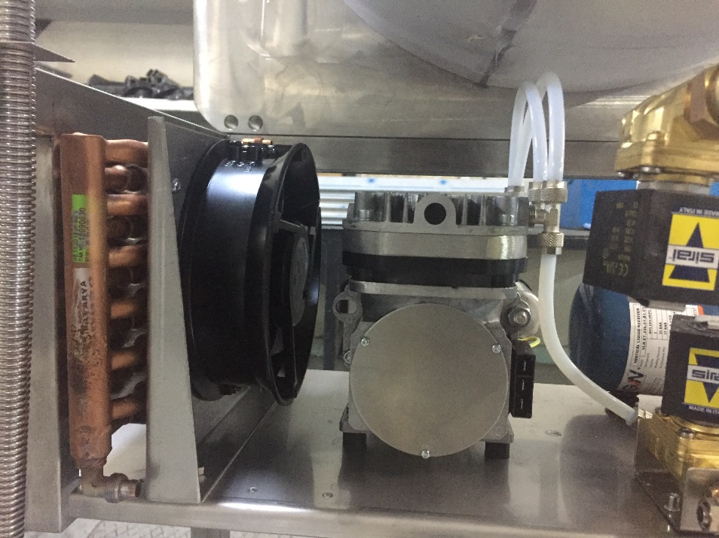

**Figure 37**

* Separate vacuum pump electrical connection terminals.
* Disconnect vacuum pump inlet and outlet hoses.
* Unscrew vacuum pump assembly screws (4 pcs).
* Disassemble input and output fittings from the old vacuum pump and assemble the new vacuum pump, carefully make hose and electrical terminal connections.

## Cooling Fan Replacement

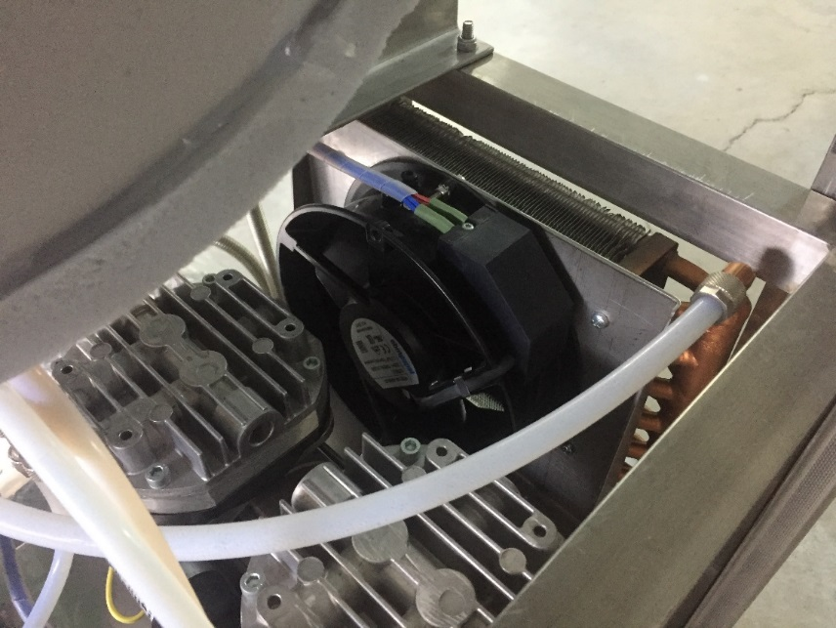

**Figure 38**

* Carefully disconnect the cooling fan electrical connections.
* Unscrew the mounting screws on the cooling fan and remove the fan.
* Mount the new cooling fan and make the terminal connections.

## Condenser Replacement

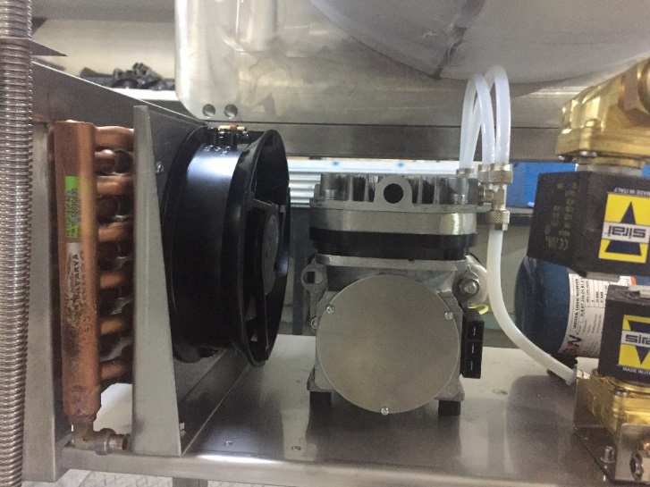

**Figure 39**

* Disconnect condenser inlet and outlet hoses.
* Remove the condenser and the sheet it is connected to by unscrewing 2 allen screws at the bottom of the mounting sheet.
* Remove the condenser by unscrewing sheet mounting screws around the condenser.
* Mount the new condenser.

## Steam Trap Replacement

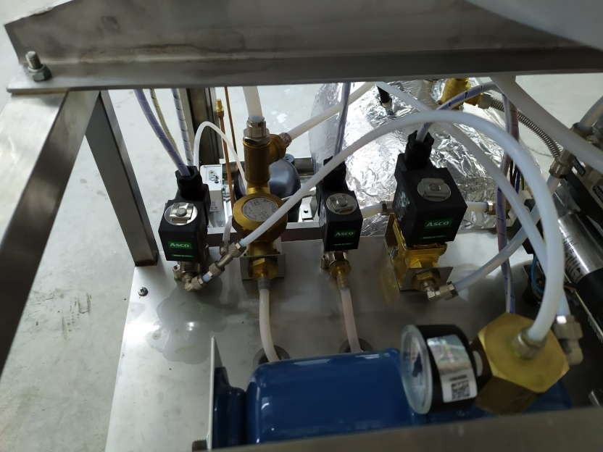

**Figure 40**

* Make sure that steam generator pressure is zero before replacing steam trap.
* Disconnect steam trap connection hose and fitting.
* Separate the steam trap mounting sheet from the frame.
* Disassemble steam trap fittings.
* Carefully mount the new steam trap.

## Compressor (Ecovat) Replacement

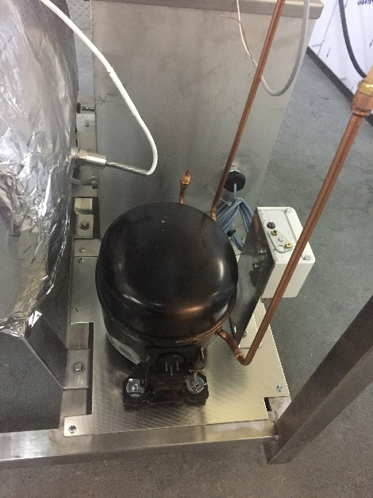

**Figure 41**

* Disconnect compressor connection hoses.
* Disconnect compressor electrical connections.
* Unscrew compressor connection screws and remove the compressor.
* Place the new compressor and make necessary connections.

## Water Level Float Replacement

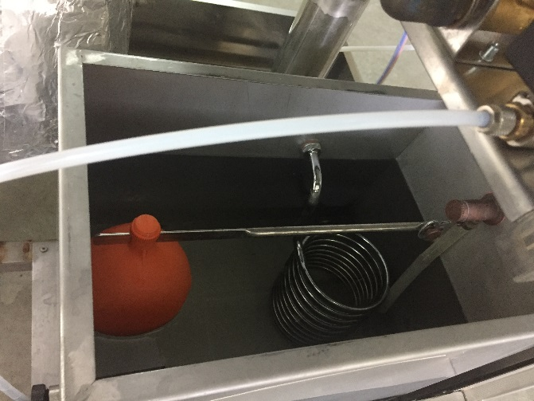

**Figure 42**

* Remove the water level float by disconnecting it from its fitting.
* Mount the new water level float.

## Gasket Replacement

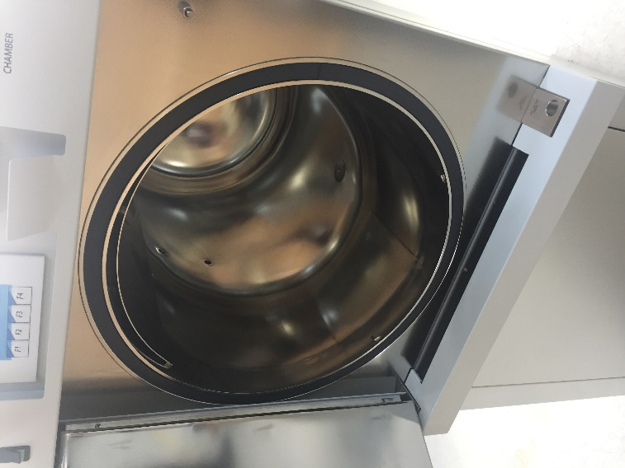 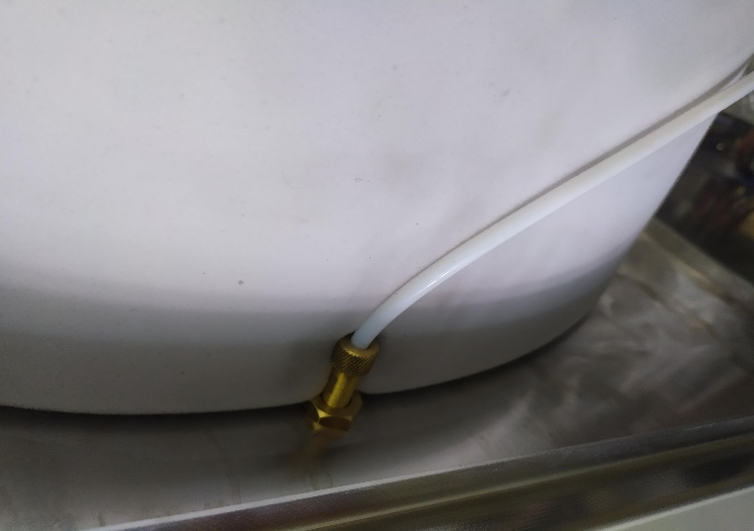

**Figure 43**

* Open the lid.
* First disconnect the air hose and then the fitting.
* Push the gasket relief valve from the rear and pull and remove the gasket from the front side.
* Affix the new gasket.
* Fixate the gasket relief valve with a nut and connect the air hose.

## Jacket Heater Replacement

* Disconnect surface thermostat and jacket heater electrical terminal connections.
* There are 4 heaters in total in 2 groups being the left and the right groups. Cut and remove the insulation material on the side of the malfunctioned heater.
* Remove heater tightening clamps, pull and remove the heater. (A group of heaters is fastened by 2 clamps.)
* Mount the new heater and make cable connections.

**5. ELECTRICAL CIRCUIT DIAGRAM**

## 5.1.NC 150 / NC 150D Electrical Circuit Diagram

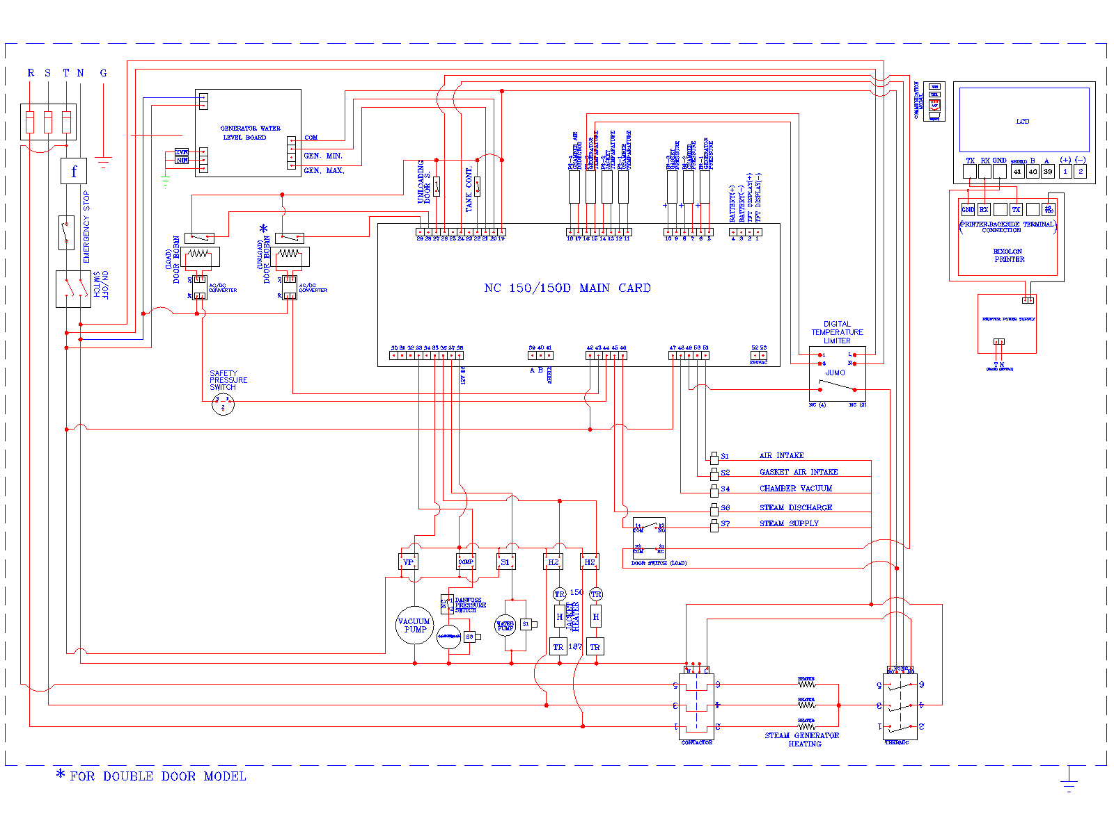

**Figure 44**